24th December 2015

**YOKOHAMA Launches High-Heat Resistant MJ Fabric Belt for Mechanical Joint**

Tokyo – The Yokohama Rubber Co., Ltd., announced today that from October it began marketing its new “High-Heat Resistant MJ Fabric Belt” for use with conveyor belts featuring mechanical joints (MJ). The new product provides heat resistance at very high temperatures, a crucial quality for conveyor belts with mechanical joint. The new belt is expected to shorten the time required to splice the belts, reduce required staff numbers, and contribute to cost reductions. YOKOHAMA has been supplying high-heat resistant conveyor belts to users that have a need for belts with hot vulcanization, such as steel mills and cement plants. YOKOHAMA developed the new product to meet the substantial need for conveyor belts with mechanical joint in overseas markets, especially in North America, and to build a more global business.

YOKOHAMA’s high-heat resistant conveyor belts have been used to transport extremely hot materials, such as coke and sintered products, which can reach temperatures as high as 400°C. To date, YOKOHAMA has promoted the use of hot vulcanization that place a small burden on operating machinery and on splice durability. However, this requires shutting down the conveyor line for long periods of time to replace the conveyor belt. On the other hand, the use of mechanical joints shortens the splice time but subjects the conveyor belt to shearing by the mechanical joint at the splicing area. To overcome this problem, YOKOHAMA made technical improvements to the carcass fabric, which has a major impact on the strength and performance of the conveyor belt.

YOKOHAMA operates conveyor belt production plants in Japan and China. To date, the Company’s conveyor belts have won the trust of many users engaged in the development of natural resources, such as coal and iron ore, in North America, Latin America, Australia, and China. Going forward, YOKOHAMA will continue to develop products that meet the various needs of its existing users and help the Company to develop new customers.

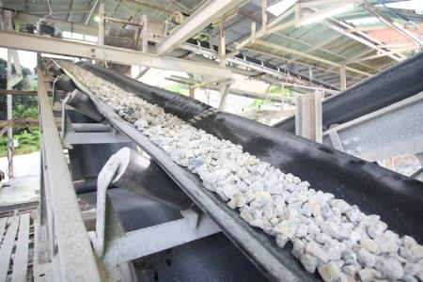

*Image of the conveyor belt*